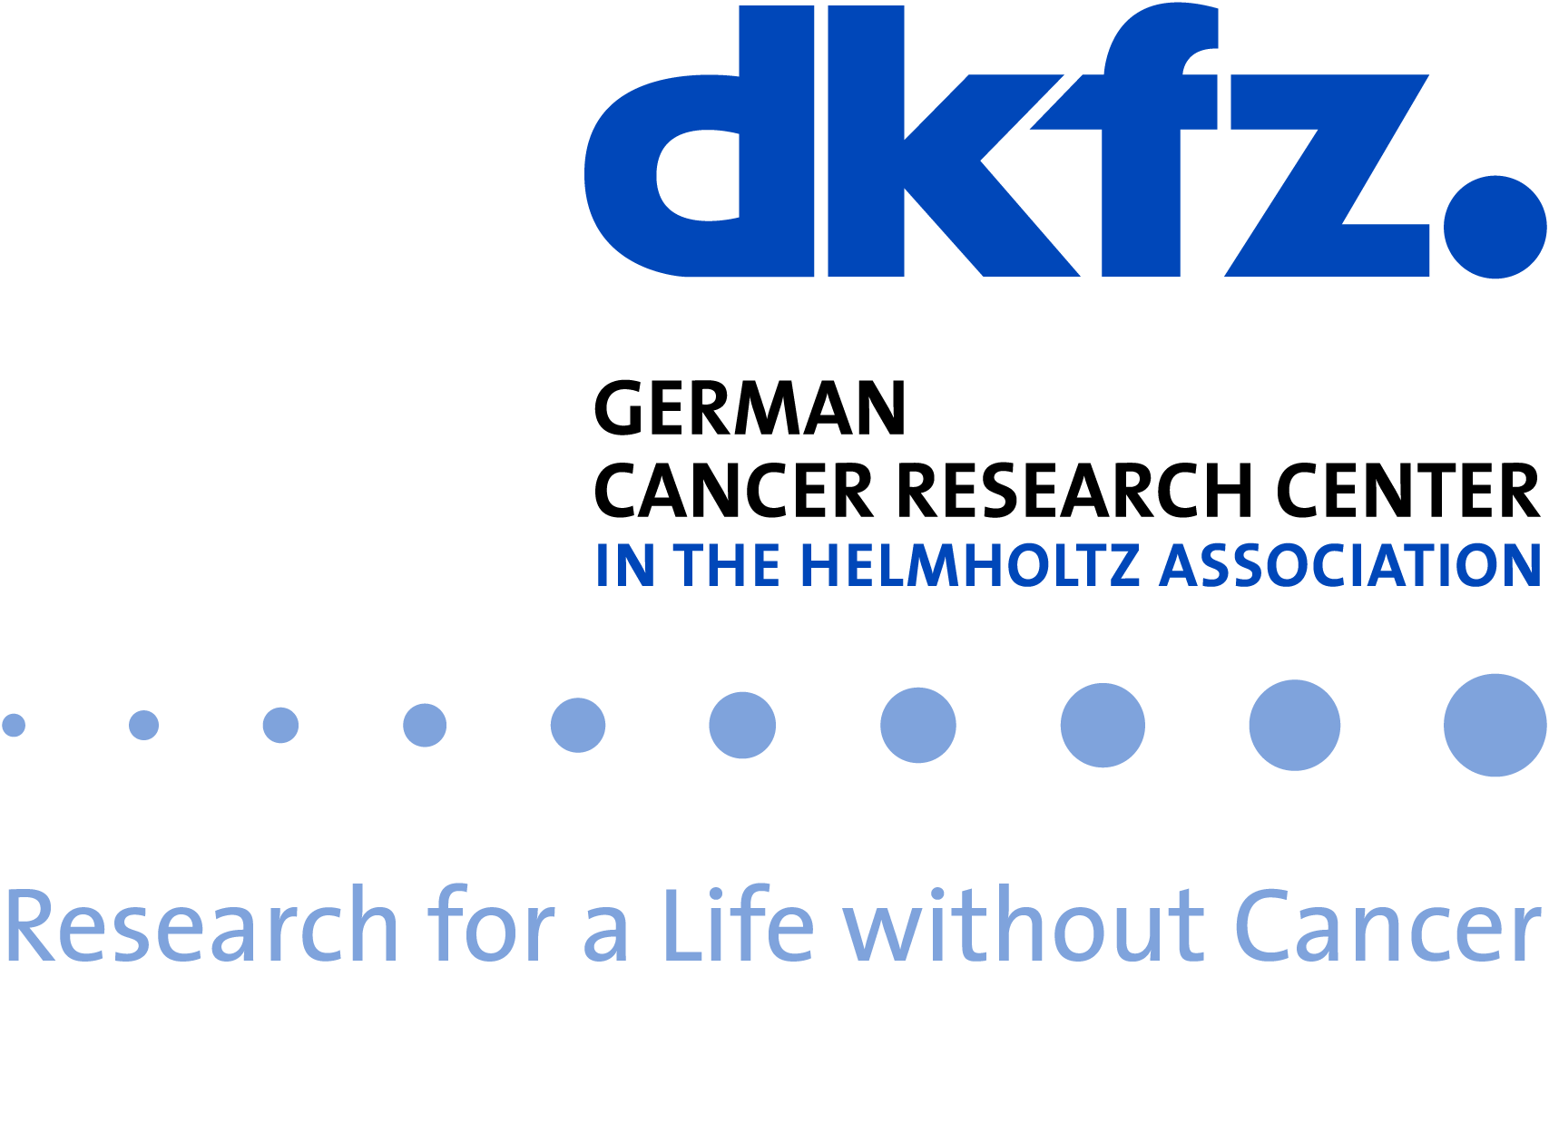

AI Health Innovation Cluster
an initiative of the Innovation Campus Heidelberg Mannheim Health & Life Sciences
Clinician Scientist Proposal
2023 Call
- Clinician Scientist Fellowship (50% funding, fixed for 12 months)
Title

Named Clinician Scientist Fellow

Project abstract [max. 200 words]

Partner institutions and Principal Investigators
Each project should be supported by two or more independent principal investigators (PIs) at the partner institutions of the AI Health Innovation Cluster. Please indicate the hosting institution.
 | Coordinator/Hosting Institution | Partner 1 | Partner 2
PI
Institution
Previous collaboration
Special funding requirements
In addition to the personnel resources, the implementation of bridge projects often requires cooperation with or adaptation of external infrastructures. This support can be provided via the central competence teams of the cluster, which cover the areas legal and data protection, data infrastructure and software development.

Summary
A justification for these resources should be provided in the project description (see below).
Expected needs from central competence teams (effort in person months):
Data Competence Center:
Software Competence Center:
Scientific Competence Center for Ethics & Law of AI:

Project description [1-2pages]
Please provide a project description with appropriate sections to provide the following information:

- Aims and expected impact of the project:
- Goal of Project, Research Question
- Development of Project
- Interdisciplinary Approach: Plan for analysis, AI methods
- Clinician Profile
- Goal for Clinician
- Prior work, existing data and/or preliminary results, including the 5 most relevant own publications
- Match to project criteria (see guidance document)
- Nature of the collaboration and management of the project
- Justification of special funding requirements (if applicable)
Curriculum Vitae of Clinician Scientist

Short Curriculum Vitae of PIs

Proposal guidelines [can be discarded prior to submission]
- Please follow these proposal template, including guide length of individual sections strictly; font size 11, line spacing 1.05, margins: top 1.5”, bottom 1”, left 1”, right 1”
- Please include a confirmation from the employer that the 50% co-funding of the clinical position is met
- Please submit your proposal latest by August 1st, 2023 via email to aih-coordination@dkfz-heidelberg.de.

