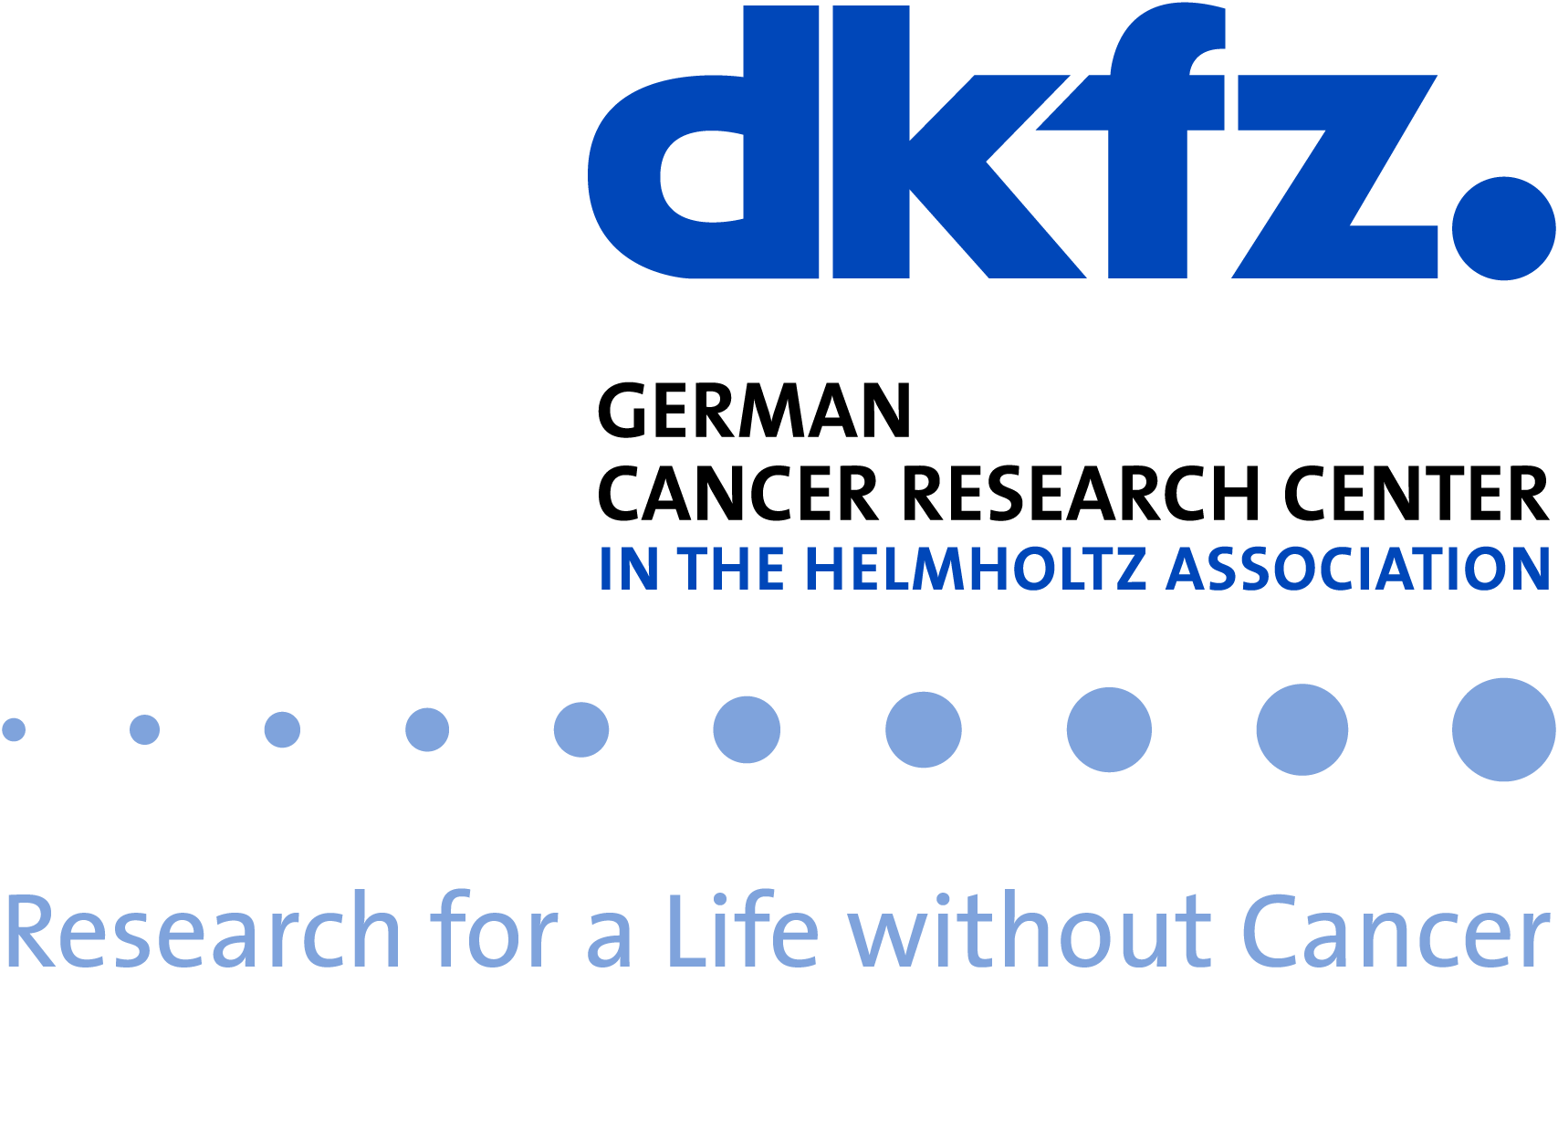

AI Health Innovation Cluster
- an initiative of the Innovation Campus Heidelberg Mannheim Health & Life Sciences

Project Proposal Call 2022

Title

Project abstract [max. 200 words]
will be made public on the website in the call for applications, by providing an abstract you give your consent to the publication.

Project type
Please indicate one of the following project types
- AI interdisciplinary postdoc (100% funding, 2y)
- Staff scientist (100% funding, 2y)
- AI Clinician Scientist (50% funding, 1y)

Named fellow
This only applies to AI Clinician Scientists (mandatory) or staff scientist proposals (optionally, only required if linked to AI interdisciplinary postdoc proposals). Please name the proposed fellow, who in parallel needs to submit an application to the call for fellows of the cluster. For clinician AI Scientists, please include a confirmation from the employer that the 50% co-funding of the clinical position is met. All other project types are competitively advertised.

Partner institutions and Principal Investigators
Each project should be supported by two or more independent principal investigators (PIs) at the partner institutions of the AI Health Innovation Cluster. Please indicate the hosting institution. PIs who are not members of the cluster at the time this proposal is submitted simultaneously apply for the project and membership of the cluster.

 | Coordinator | Partner 1 | Partner 2
PI
Institution
Previous collaboration
(y/n)

Special funding requirements
In addition to the personnel resources, the implementation of bridge projects often requires cooperation with or adaptation of external infrastructures. This support can be provided either in the form of an additional cash contribution, or via the central competence teams of the cluster, which cover the areas legal and data protection, data infrastructure and software development. A justification for these resources should be provided in the project description (see below).
Special funding requirements (cost in EUR):
Expected needs from central competence teams (effort in person months):
Ethical-legal:
Data technology:
Software:

Project description [1-2pages]
Please provide a project description with appropriate sections to provide the following information:

- Aims and expected impact of the project
- Goal of Project
- Development of Project
- Interdisciplinary Approach
- Required Candidate Profile
- Goal for Candidate
- Prior work, existing data and/or preliminary results, including the 5 most relevant own publications
- Match to project criteria (see guidance document)
- Nature of the collaboration and management of the project
- Justification of special funding requirements (if applicable)

Short Curriculum Vitae of PIs

Proposal guidelines [can be discarded prior to submission]
- Please follow these proposal template, including guide length of individual sections strictly; font size 11, line spacing 1.05, margins: top 1.5”, bottom 1”, left 1”, right 1”
- Please name the file AIH_last name of the coordinating PI
- Please submit your proposal latest by June 15th, 2022 via email to AIH-Office@dkfz.de

